Date: 09/06/2026
Internship Experience Letter

To,
Simran Sheikh

This Letter is to Certify that, Simran Sheikh, has successfully completed her internship program of 7 Months with Lextria Research. Her internship period was from 01-11-2025 to 31-05-2026. She was working with Intellectual Property Team (Patent) and was actively involved in the projects and task assigned to her.

During the span, we found her to be a punctual and a reliable person. Her learning capabilities are good and she picks up quickly. Her feedback and evaluation proved that she learned strongly. Moreover, her interpersonal and communication skills are brilliant.

We wish her a bright future.

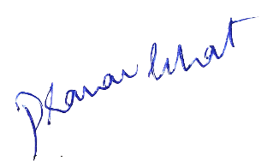
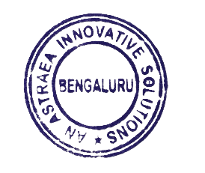
Sincerely,

Adv Pranav Bhat,
IP Strategist and CEO,
An Astraea innovative solutions

